**Chapter 2 - Biodiversity**

**All Lectures Uploaded on YouTube:**

[**https://tinyurl.com/fkm9-biology**](https://tinyurl.com/fkm9-biology)



**2.1. Definition and Introduction to Biodiversity**

The similarity among living organisms is that they share all the characteristics of life, i.e., movement, respiration, sensitivity, nutrition, excretion, reproduction and growth. At the same time these living things differ from one another and their variety is enormous.

* Biological diversity is the variety of living organisms on Earth.
* It provides us with nourishment, housing, fuel, etc.

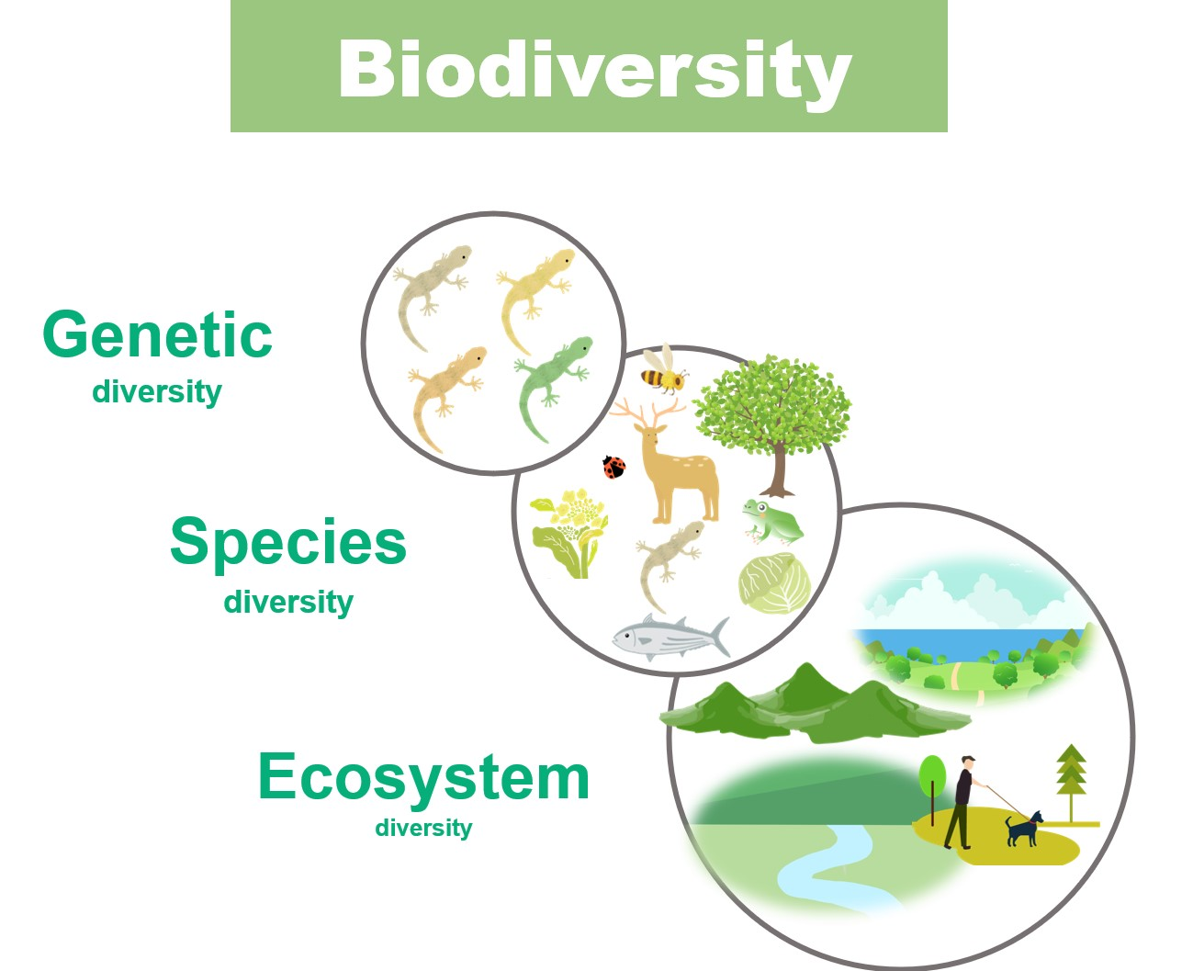

**2.2. Classification**

It relates to grouping (classifying) related facts into classes. To group similar things and separate, unlike/dissimilar things.

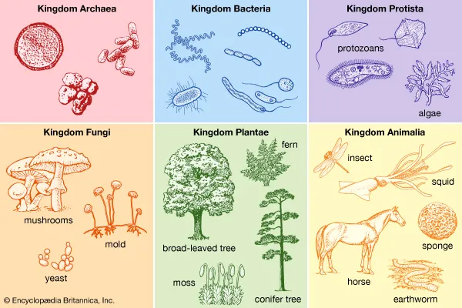

**Advantages of Classification**

Classification helps in grouping organisms based on similarities and differences, and to study them systematically

* **Objectives:**

1. To *determine* similarities and differences
2. *Arrange* organisms systematically
3. Identify organisms for *study*
4. *Understand* evolutionary relationships

**2.3. History of Classification**

The Greek philosopher Aristotle was the first person who classified the living organisms. In the 700s, Abu Usama Aljahiz described 350 species of animals. Additionally,

1. **Andrea Caesalpino** grouped plants into 15 groups and called them genera
2. **John Ray**: classification of plants systematically
3. **Tournefort** introduced class and species taxonomy
4. **Carolus Linnaeus** grouped species by physical characteristics

According to the earlier classification system, organisms were classified into two kingdoms, then a three-kingdom and then five-kingdom system.

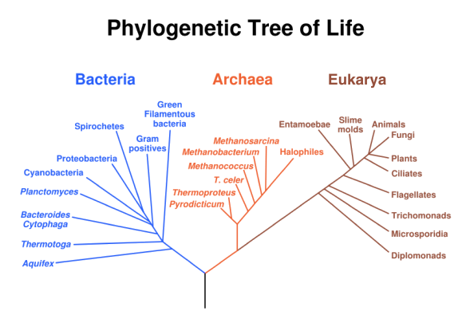

1. **Two-kingdom system**: divides organisms into *Plantae and Animalia* (plants and animals)

2. **Three-kingdom system**: *Protista* for unicellular organisms

3. **Five-kingdom system:** *Monera, Protista, Fungi, Plantae and Animalia*

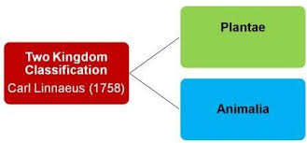

**2.4. Classification - The Three Domains System**

In biology, a domain means the largest of all groups in the classification of life. Domain is group of kingdoms or taxonomic category above the kingdom.

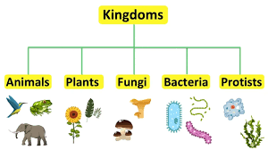

**1. The Domain Archaea**

The domain Archaea has the following characteristics:

a. Archaea are prokaryotic cells.

b. The cell walls of Archaea contain no peptidoglycan.

c. The rRNA (ribosomal RNA) are not found in Bacteria and Eukarya.

d. Archaea are not sensitive to some antibiotics that affect bacteria. They are sensitive to some antibiotics that affect the Eukarya.

e. Archaea often live in extreme environments.

f. Archaea membrane can withstand higher temperature and stronger acid concentration.

g. Archaeal creatures include : Methanogens, Halophiles, Thermoacidophiles.

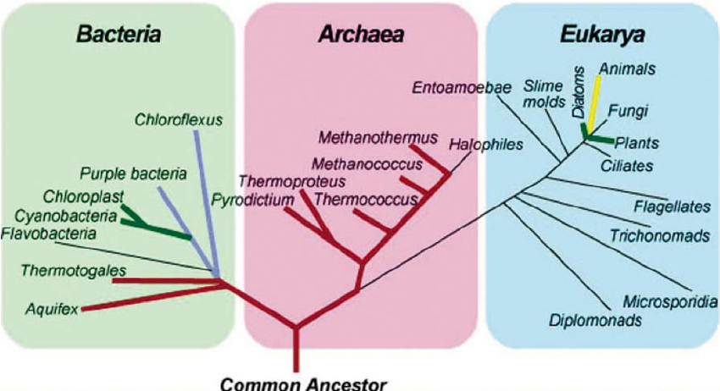

**2. The Domain Bacteria** 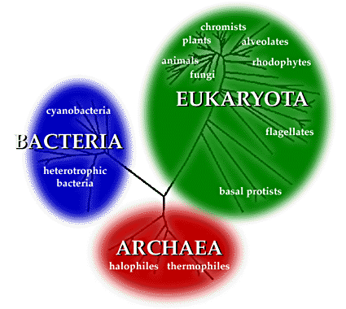

The domain bacteria have the following characteristics:

a. Bacteria are prokaryotic cells.

b. The cell walls of bacteria contain peptidoglycan.

c. They contain rRNA that is unique to bacteria.

d. Bacteria are sensitive to traditional antibacterial antibiotics but are resistant to most antibiotics that affect eukarya.

**3. The Domain Eukarya**

The domain Eukarya (also spelled Eucarya) have the following characteristics:

a. Eukarya have eukaryotic cells.

b. Not all Eukarya have cells with a cell wall. Their cell wall contains no peptidoglycan.

c. Eukarya contains rRNA that is unique to Eukarya.

d. Eukarya are resistant to traditional antibacterial antibiotics but are sensitive to most antibiotics that affect eukaryotic cells.

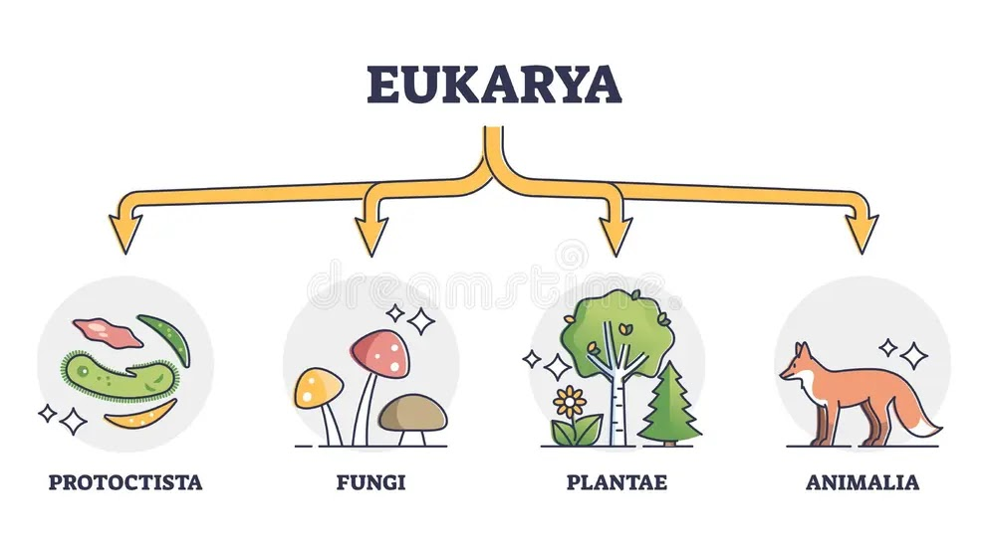

The domain Eukarya are divided into four kingdoms: Protista, Fungi, Plantae and Animalia.

* **Protista:** A diverse group of mostly single-celled organisms, which includes algae and protozoans. This kingdom is considered polyphyletic, meaning its members are not all more closely related to each other than they are to members of other kingdoms.
* **Fungi:** Organisms that are unicellular or multicellular and obtain nutrients through absorption, such as yeast, molds, and mushrooms. Fungi are distinct from plants and animals.
* **Plantae:** Multicellular organisms that have cell walls and produce their own food through photosynthesis. This kingdom includes mosses, ferns, and flowering plants.
* **Animalia:** Multicellular organisms that lack cell walls, obtain nutrients by ingestion, and are typically mobile. This kingdom includes sponges, insects, and vertebrates.

**2.5. Taxonomic Ranks of Classification**

* The groups into which organisms are classified are known as taxonomic ranks or categories
* Total main ranks as follows;

1. **Domain**- the largest and most inclusive group of all
2. **Kingdom**- the highest and broadest category. E.g., Animalia, Plantae etc
3. **Phylum** (or Division in plants)- a group of related classes sharing basic characteristics. E.g., Arthropods
4. **Class**- a group of related orders or specific similarities. E.g., mammals or birds
5. **Order**- further division within a class (related families). E.g., carnivorous animals
6. **Family**- closely related organisms within an order. E.g., cats or apes
7. **Genus**- closely related and very similar species. E.g., big cats like lions and tigers or *Homo*
8. **Species** are similar individuals that can **interbreed** and produce fertile offspring. E.g., *Homo* sapiens

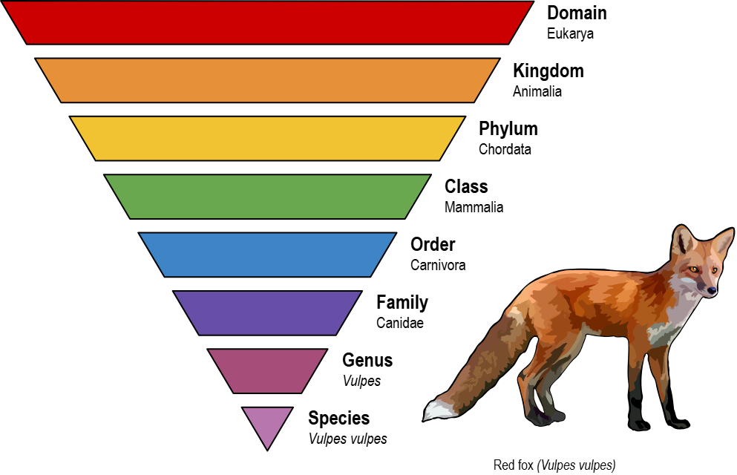

**2.6. Species**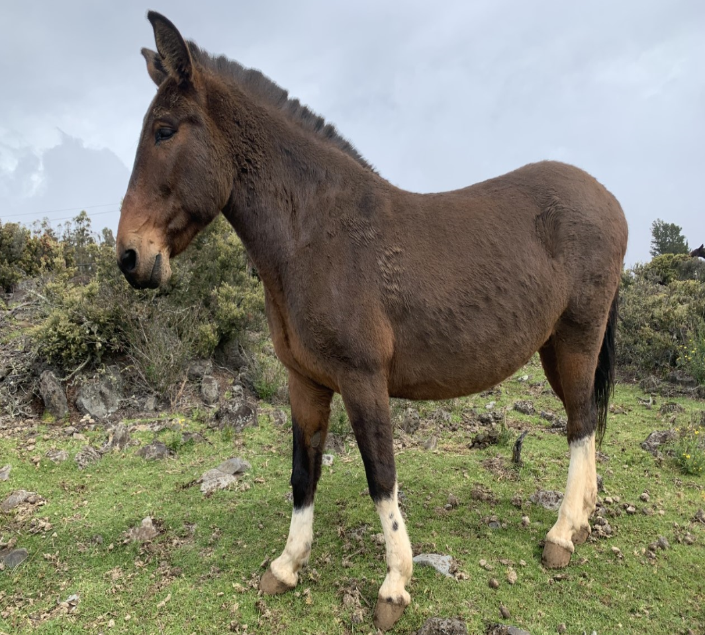

A **species** is a group of organisms capable of interbreeding to produce fertile offspring. Example: Mule (an infertile hybrid of a male donkey and a female horse).

It is infertile, because of the odd number of chromosomes, they can't reproduce. So, it is not a species. Species is the most basic unit of classification, as well as a taxonomic rank.

**2.7. Binomial Nomenclature**

**Carolus** Linnaeus introduced Binomial Nomenclature and consists of genus and species names.

* The first term of the name indicates the genus, and the second term indicates the species of the organism

**Importance of Binomial Nomenclature**

Provides a universal naming system to avoid confusion due to language differences.

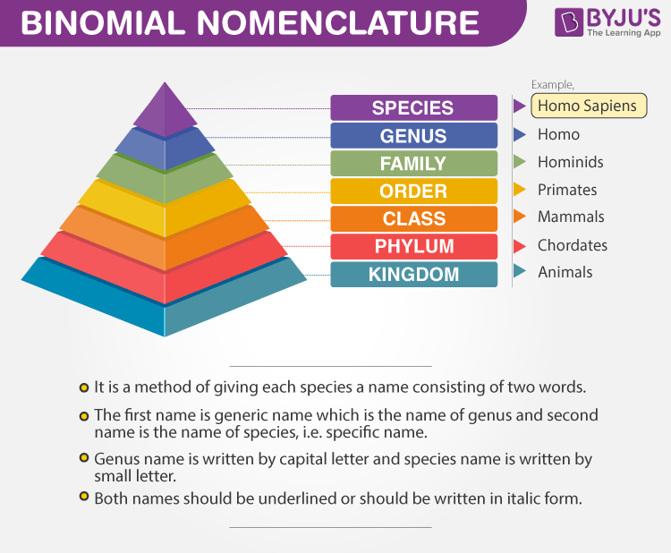

**2.8. Complications of Classifying Viruses**

Viruses exhibit both living and nonliving characteristics.

* **Living traits:** Variety, genetic material, reproduction in host cells (e.g., humans), and causing diseases.
* **Non-living traits:** Lack cellular structure, can be crystallised, does not respire.
* Viruses are not included in any kingdom due to their borderline nature between living and nonliving.

Viruses are at the borderline of living and non-living. So, they are not included in any domain and kingdom under modern classification.



